



**Project and Professionalism(6CS007)**

**Survey Equipment Rental**

**(Artefact Design and Test Plan)**

Student ID : 2358836

Student Name : Mausham Dhakal

Group : L6CG19

Supervisor : Mr. Nikunja Lamsal

Reader :Mr. Shiv Kumar Yadav

Submitted on :02-02-2025

**Table of Contents**

Functional Decomposition Diagram 4

Test Cases for Rental eCommerce Website 5

User Management 7

Er Diagram 7

Class Diagram 8

Activity Diagram 9

Use case Diagram 10

Sequence diagram 11

Product management 12

Er diagram 12

Class diagram 13

Activity Diagram 14

Use Case Diagram 15

Sequence Diagram 16

Payment methods 17

Er diagram 17

Class diagram 18

Activity diagram 19

Use case diagram 20

Sequence diagram 21

Notification management 22

Er diagram 22

Class diagram 23

Activity Diagram 24

Use case Diagram 25

Sequence diagram 26

Artefact Design 27

**Table of Figures**

Figure 1: login page 27

Figure 2: Product page 28

Figure 3: Rent pages 28

Figure 4: Payment Pages 28

Figure 5: Sign up page 28

Figure 6: product page 28

Figure 7: rent page 28

Figure 8: Payments 28

Figure 9: login pages 28

Functional Decomposition Diagram A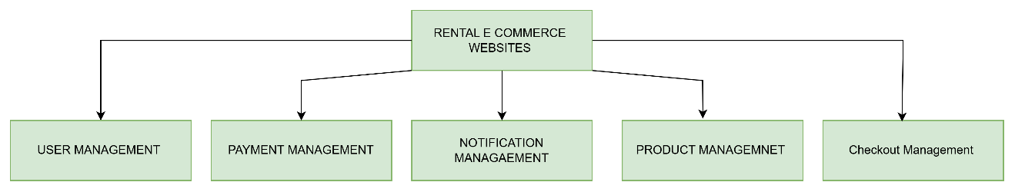

**wireframe**

**Testing**

**Implementation**

**(Coding)**

**STD Diagram**

**Collaboration diagram**

**Sequence**

**Diagram**

**Class**

**Diagram**

Data

Dictionary

**ERD**

**Conceptual, Detailed**

**Activity Diagram**

**User case Diagram**

**Product Backlog**

**(SRS)**

**Sprint**

**Planning**

**pa**

**Process modeling**

**Prototyping**

**Testing**

**execution**

**Date modeling**

**Process &**

**Context modeling**

User Management

**Testing**

**documentation**

**Artefact**

**Poster**

**Requirements**

**Modeling**

**Project**

**Planning**

**Artefact Design Document**

Fig: *Functional Decomposition Diagram*

**UM -F-1.0**

**Numbering**

**Types of the Requirements**

**F: Functional Requirement**

**NF: Non- functional Requirements**

**UR: Usability Requirements**

**Sub system**

**UM: User management**

**PM: Product management**

**MM: payment management**

**NM: Notification Management   
SM: Order Management**

# Test Cases for Rental eCommerce Website

|  |  |  |  |  |  |  |
| --- | --- | --- | --- | --- | --- | --- |
| Test Case ID | Test Name | Test Description | Expected Result | Observation | Evidence | Result |
| T01 | Login | Verify that users can log in with valid credentials. | User should be able to log in and access the dashboard. | User successfully logged in with valid credentials, and access to the dashboard was granted. | Refer to Screenshot 1 | Pass |
| T02 | Invalid Login | Verify that an error message appears for incorrect credentials. | User should see an error message when using invalid credentials. | User entered incorrect credentials, and an error message was displayed. | Refer to Screenshot 2 | Pass |
| T03 | User Registration | Verify that a new user can successfully register. | User should be able to create an account. | User filled out the registration form, submitted it, and received confirmation. | Refer to Screenshot 3 | Pass |
| T04 | Browse Equipment | Ensure that users can view the list of available survey equipment. | Equipment list should be displayed properly. | User navigated to the equipment page, and all items were displayed correctly. | Refer to Screenshot 4 | Pass |

|  |  |  |  |  |  |  |
| --- | --- | --- | --- | --- | --- | --- |
| T05 | Equipment Details | Verify that users can view detailed information on an item. | Clicking on an item should open a details page. | User clicked on an item, and the detailed information was displayed correctly. | Refer to Screenshot 5 | Pass |
| T06 | Checkout page | Verify that the checkout page is shown correctly. | The checkout page should show all the input fields and users can fill the form. | User was shown the checkout form correctly and user was able to fill all the input fields. | Refer to Screenshot 6 | Pass |
| T07 | Logout | Ensure users can log out and be redirected to the login page. | Users should be logged out and redirected to the login page. | User clicked 'Logout' and was redirected to the login page. | Refer to Screenshot 7 | Pass |

# User Management

## Er Diagram

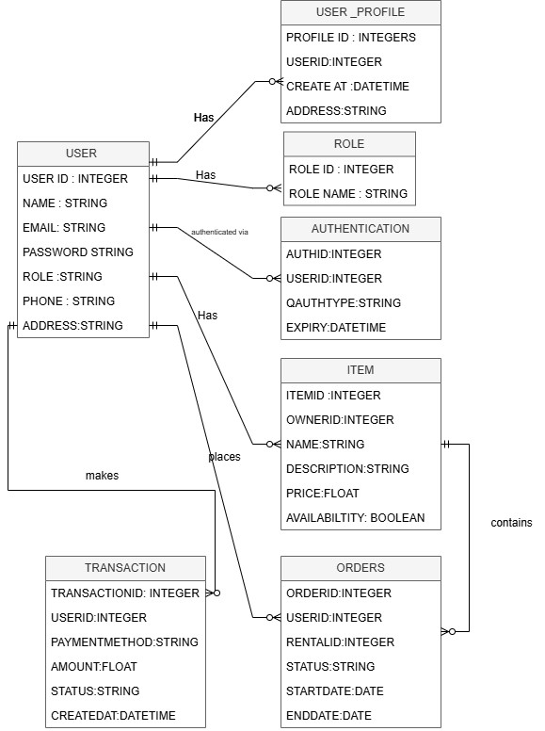

Class Diagram 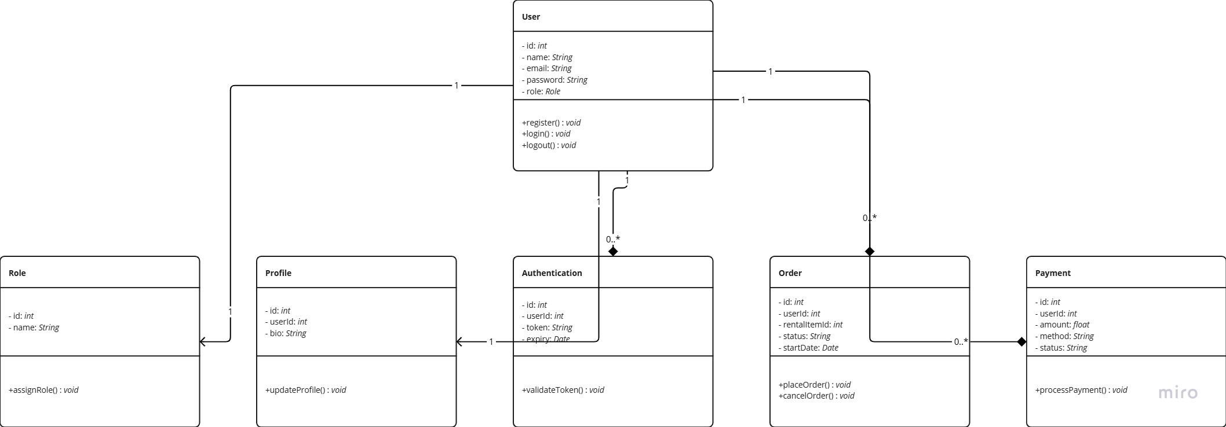

## Activity Diagram

No

No

yes

Logout (end session )

Return to the login/Register

Shows errors

User can browse the item, check orders etc

User navigates to dashboard

User login Successfully

Valid credentials

System verifies email/password or Oauth login

Completed Registration

New user

User select the login/Register

User visit the Websites

yes

## Use case Diagram

List the item

View the rent

Register

**Owner**

login

Edit the profile

**Customers**

Rent item

View the orders

Log out

**Admin**

Manage the user

Manage transaction

View report

## Sequence diagram

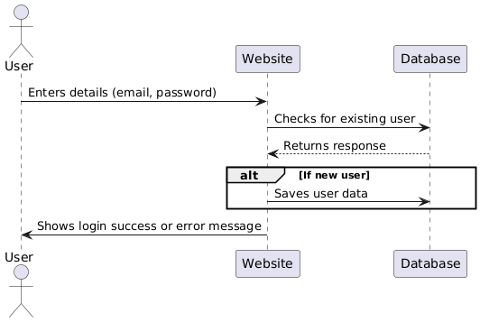

# Product management

## Er diagram

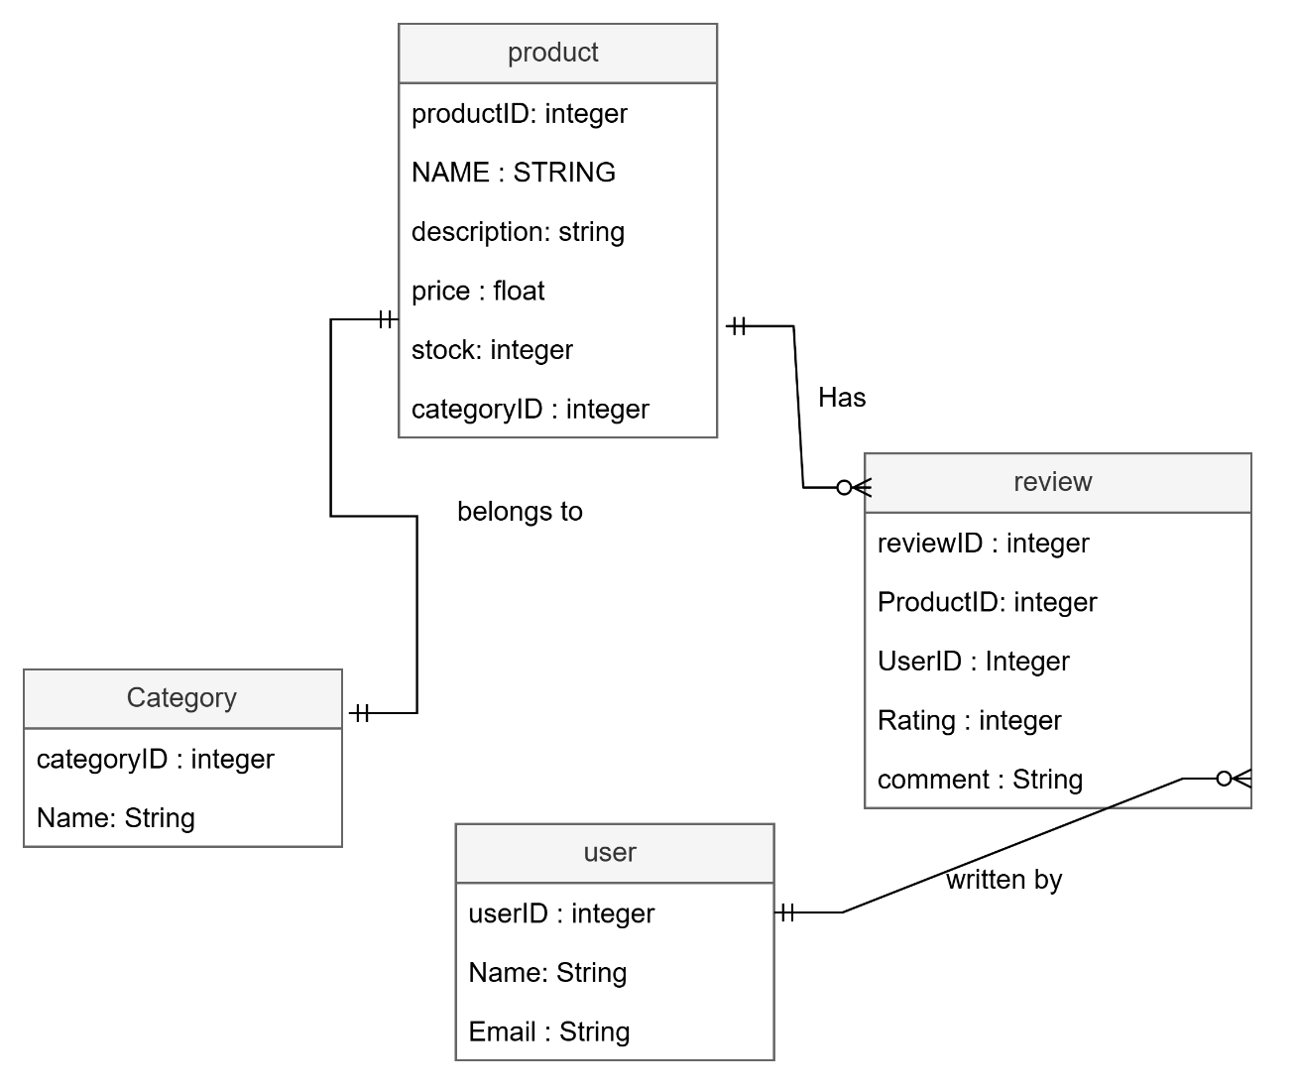

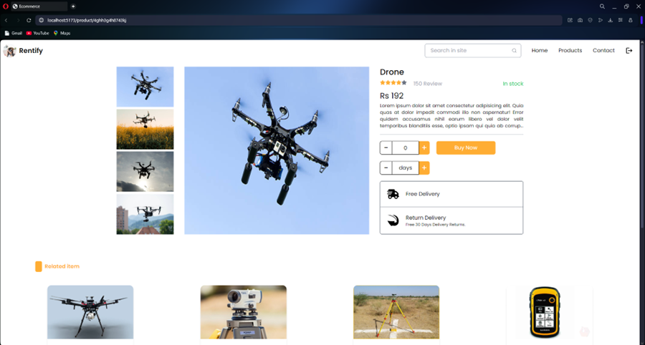

## Class diagram

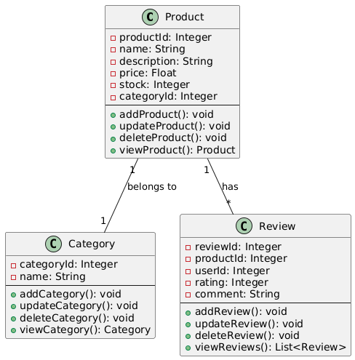

## Activity Diagram

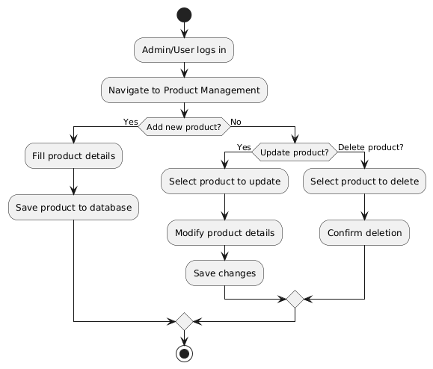

## Use Case Diagram

**User**

View Review

Writer review

View Product

Delete product

Update product

Add product

**Admin**

## Sequence Diagram

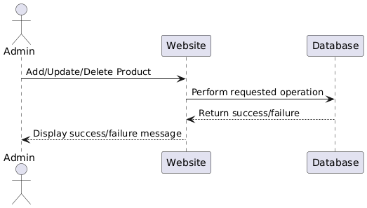

# Payment methods

## Er diagram

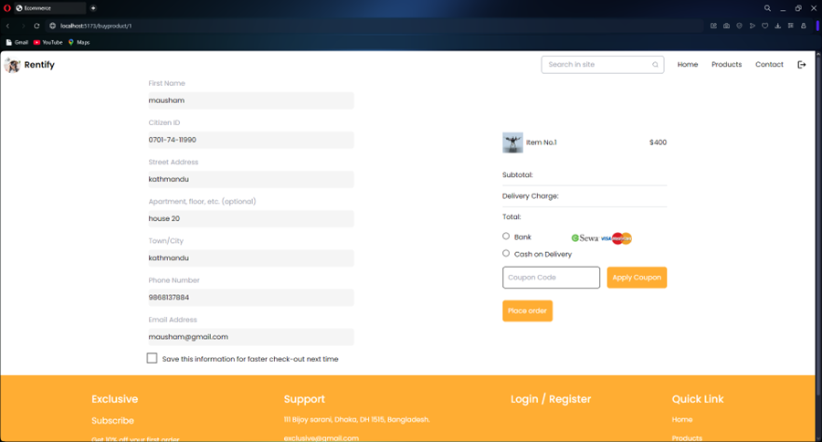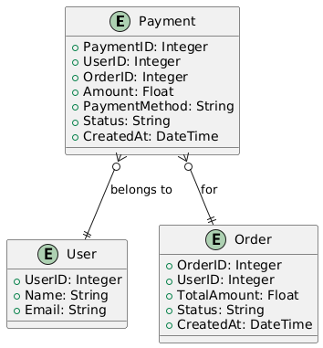

## Class diagram

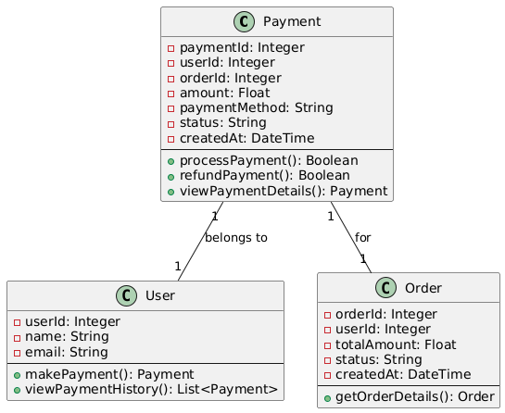

## Activity diagram

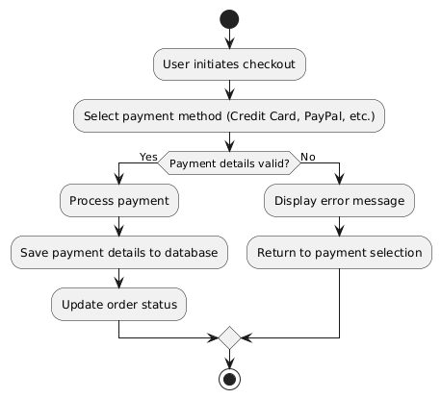

## Use case diagram

Make Payment

**Client**

**View payment History**

**Refund payment**

**Admin**

**Manage Payment**

## Sequence diagram

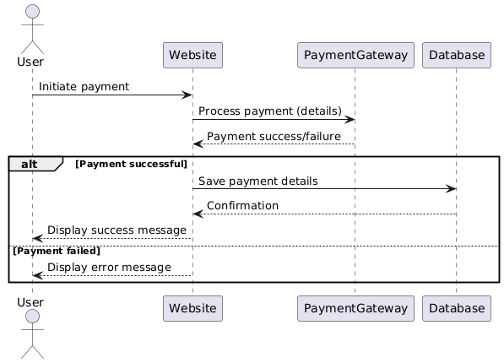

# Notification management

## Er diagram

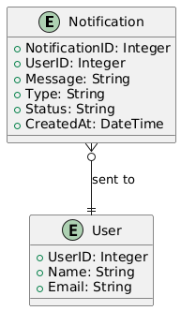

## Class diagram

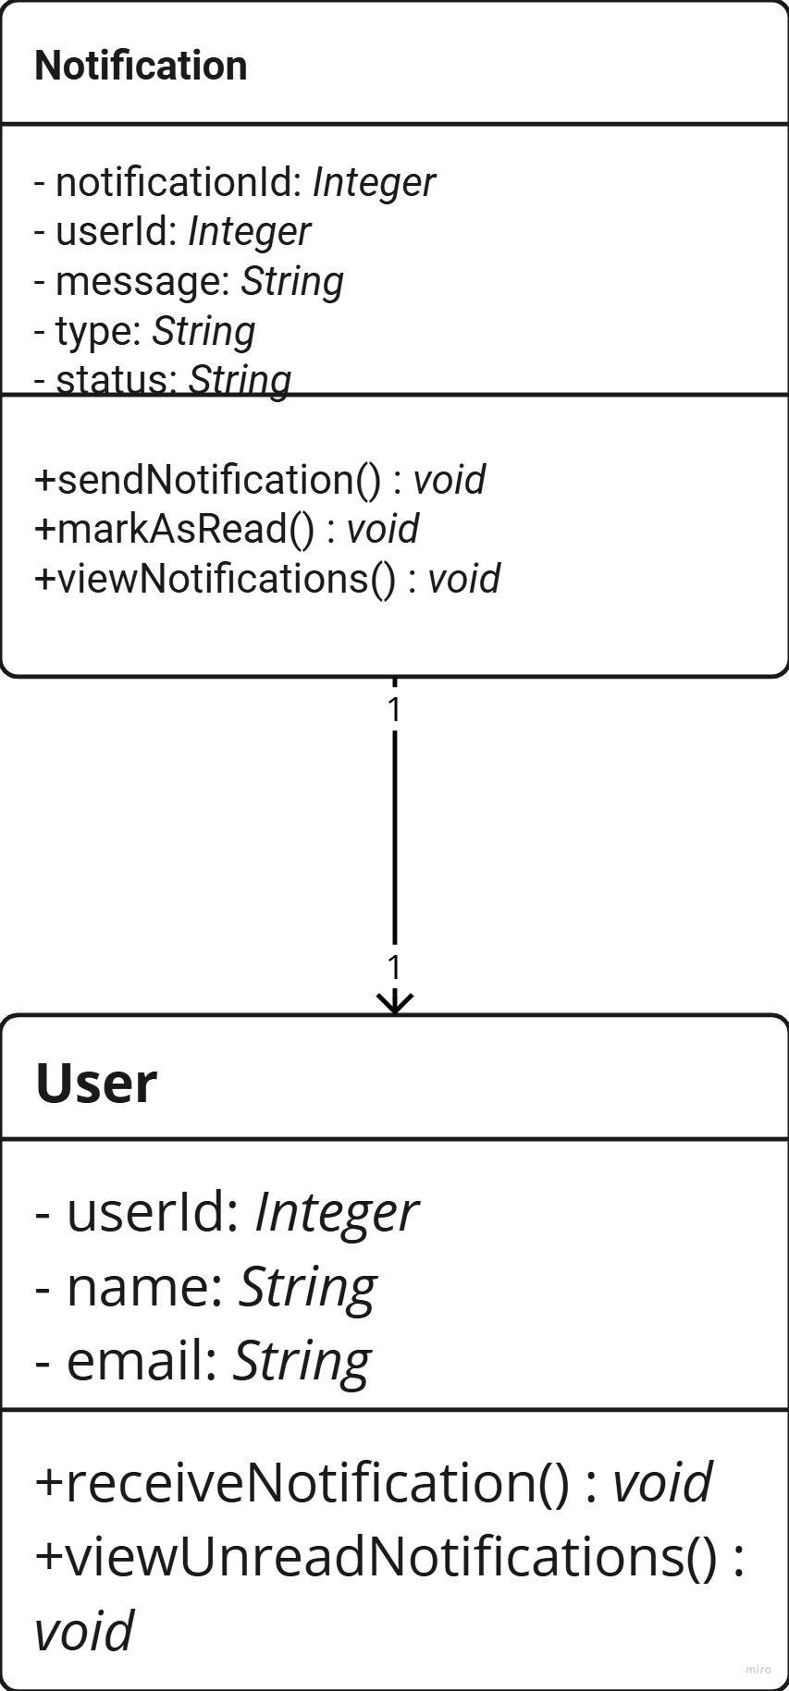

## Activity Diagram

Send notification (e.g. new orders payment status)

Create the notification object

Save the notification to the database

Send notification to the user (email, websites)

Notification read?

No

yes

Keep as unread

Make as read

Use case diagram

## Use case Diagram

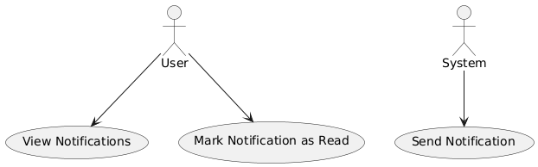

## Sequence diagram

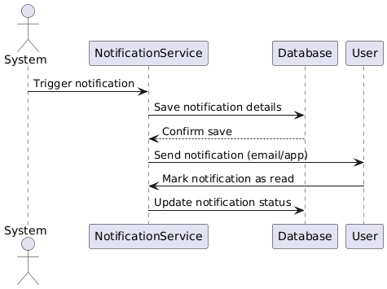

# Artefact Design

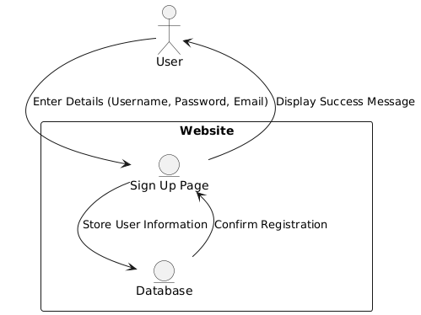

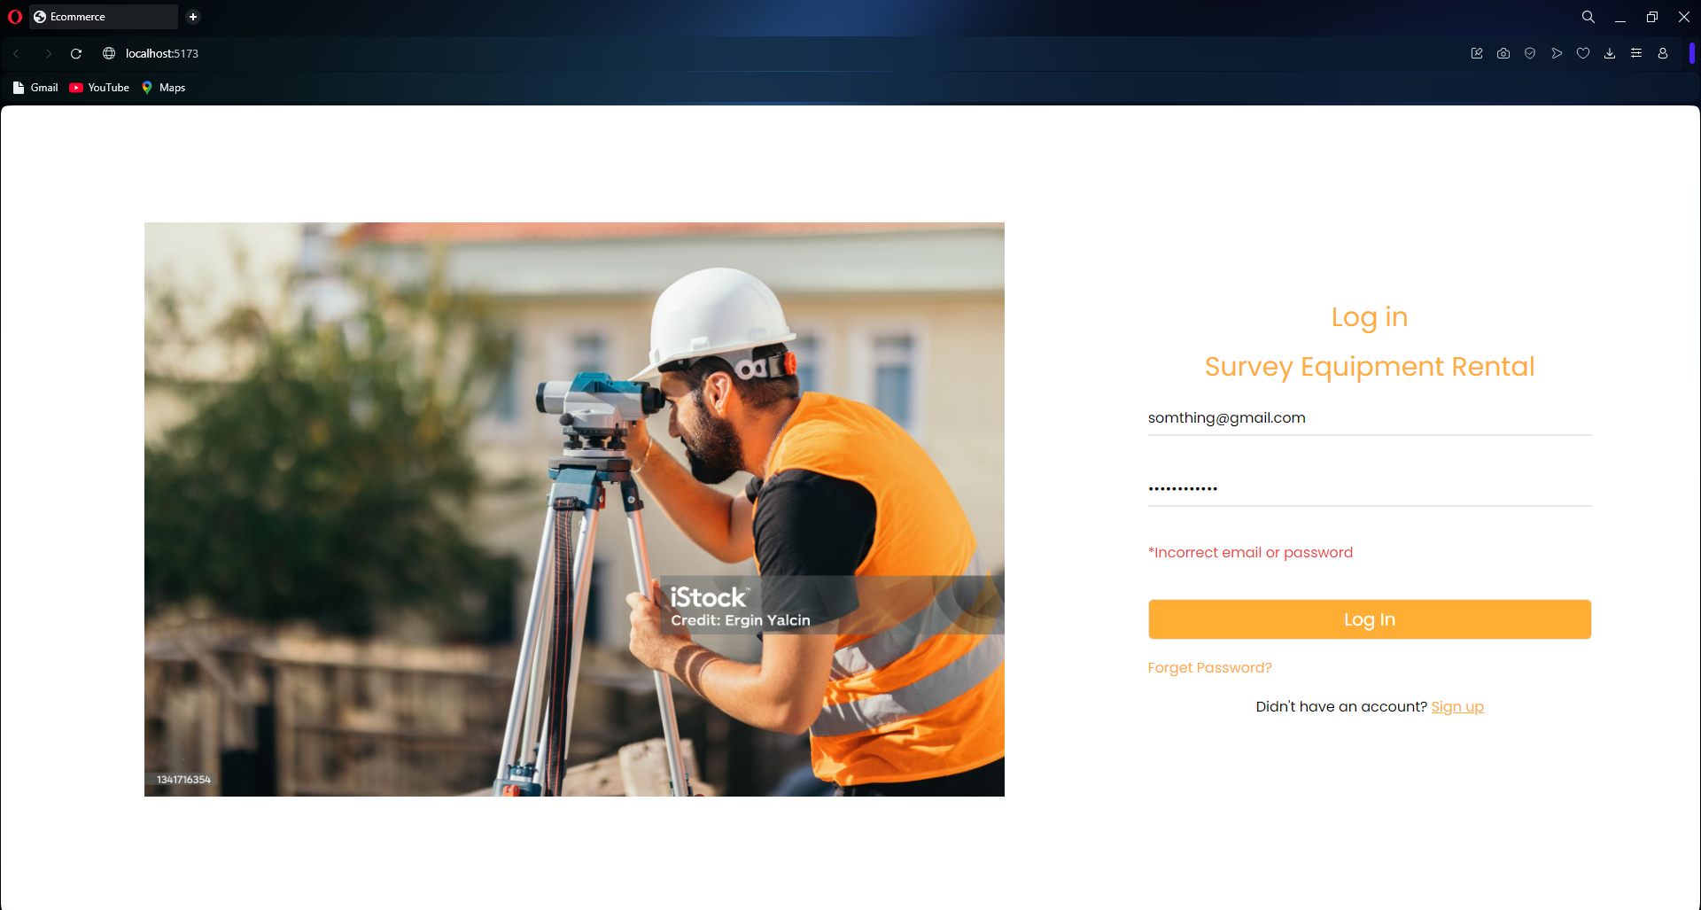

Figure : login page

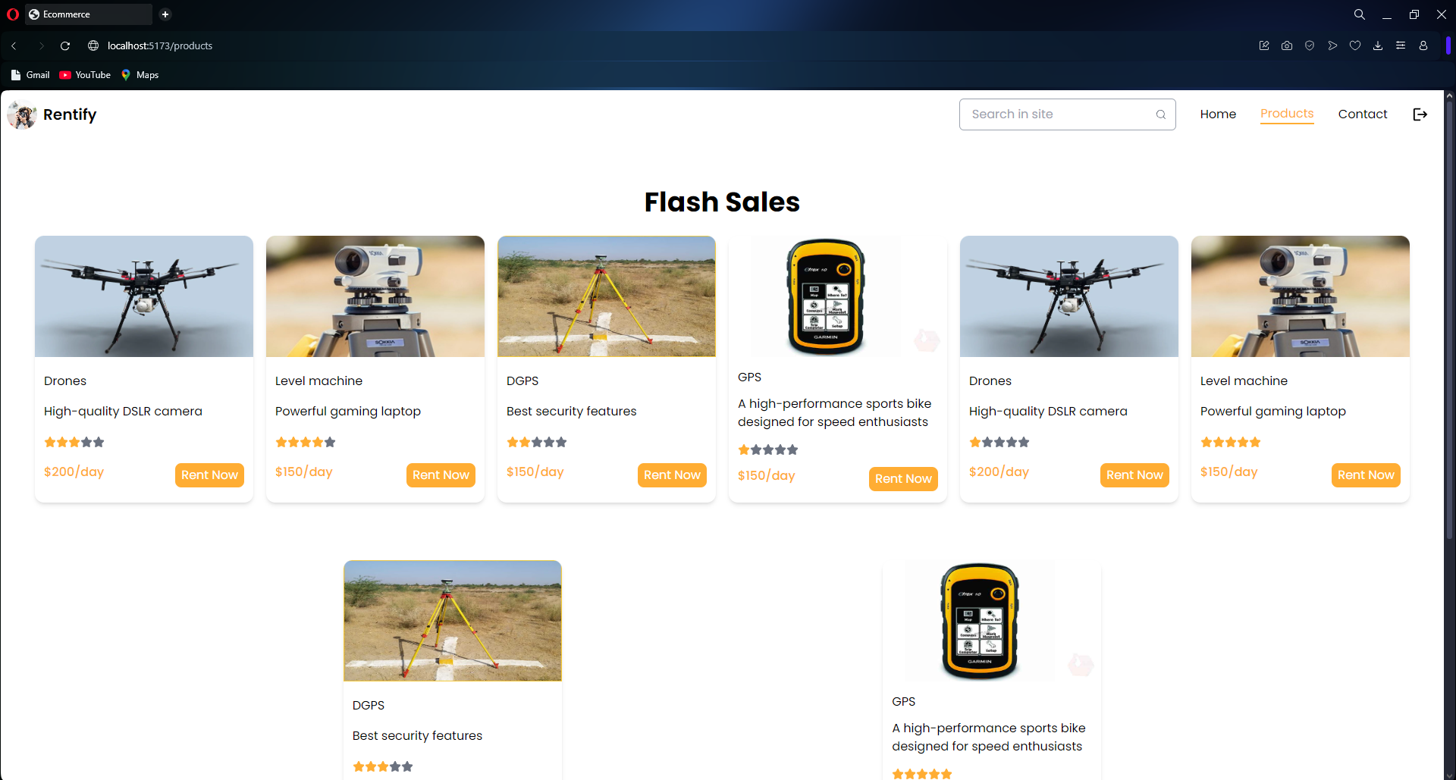

Figure : Product page



Figure : Rent pages



Figure : Payment Pages

Login pages

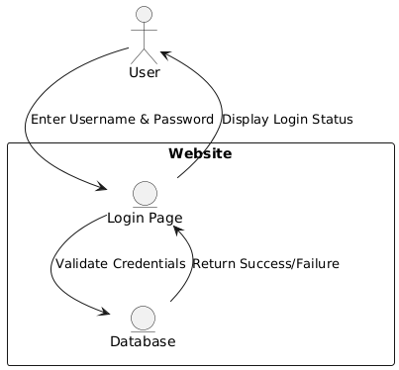

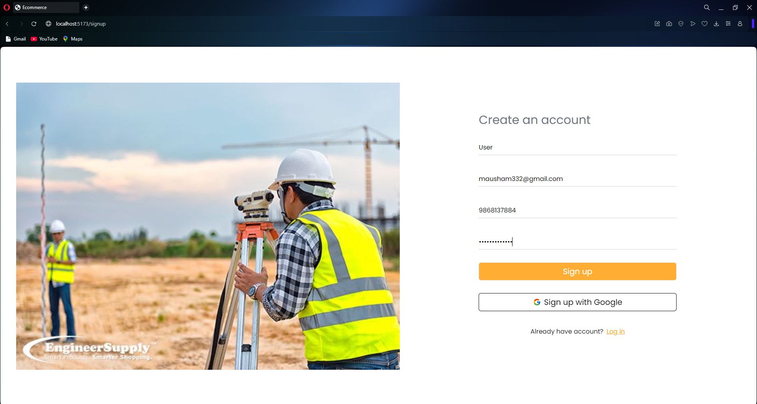

Figure : Sign up page



Figure : product page



Figure : rent page



Figure : Payments

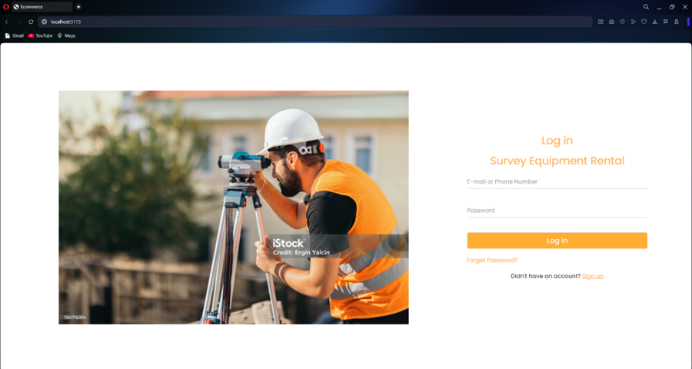

Figure : login pages